Predicting Road Accident

Hotspots Using Weather, Traffic and Social Data

# GROUP NAME: DATA VIGILANCE

GROUP MEMBERS:

Mahanth V

R Abhiishek

Sujit Muthukumarasamy

Guru B

# Problem Statement

Emerging cities have to deal with road accidents as a serious and recurring issue. Unfortunately, This kind of issue endangers lives, damages property, and adds to the ever-growing problem of traffic congestion. Preventive action taken these days is of a reactive nature, proving the lack of adequate and effective road safety measures that are taken prior to an incident. In addition, current road safety measures lack the consideration of several important factors, namely changing weather, the time of the day, visibility, and social situations that pose risks for road users. This has led to poorly configured resource allocation concerning accident hotspots. There is an important need for an intelligent and integrated data approach that combines and analyzes traffic, weather, and social datasets to identify potential accident hotspots to facilitate proactive planning, enable prompt emergency response, and enhance the safety of all road users in urban areas.

# Proposed Solution

We will develop an AI system which puts together traffic, weather, time, and social event info to identify at risk areas for accidents in real time. We will present a city dashboard for authorities which reports risk areas, which in turn they may use to deploy emergency services and take proactive traffic measures. Also we will have a mobile app which gives drivers live reports of high risk areas and put forth safe alternate routes. The model will update predictions as conditions change which may include rain, fog, visibility issues, rush hour, large events but also will give city officials the ability to validate and adjust results as they see fit. By putting many data sets into one smart system we aim to see better resource allocation, reduced traffic, and most of all saved lives.

# Detailed FlowChart

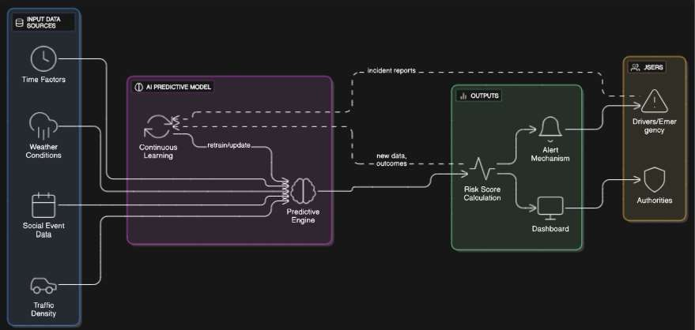

# Wow Factor

Real-time prediction of accidents before they happen.

Multi-factor analysis combining weather, traffic, events, and temporal patterns.

Visual dashboards for authorities with actionable insights.

Potential to save lives and reduce traffic congestion significantly

# Future Scope

Expand model to cover multiple cities or regions.

Incorporate IoT data from connected vehicles for real-time predictions.

Integrate with emergency services to reduce response times.

Develop personalized driver risk scores for insurance and safety programs.

• **Data Sources** → Traffic APIs, Weather APIs, Social Event Feeds

• **Data Preprocessing** → Cleaning & Feature Extraction

• **ML Model (Random Forest / XGBoost)** → Predicts risk level

• **Flask API** → Serves predictions

• **Streamlit Dashboard** → Displays live accident hotspot map

# Technology stack

•**Platform:** IBM Data Science / ML Platform

•**Tools:** Python, Jupyter Notebook, IBM Watson, Tableau/Power BI

•**ML Algorithms:** Random Forest, Gradient Boosting, XGBoost, Neural Networks

•**Datasets:** Public traffic data, historical accident records, weather datasets, social event schedules, GPS data

# Conclusion

The incorporation of traffic density, weather conditions, time of day, social events, and historical accident data leads to improved and more accurate road accident predictions. This thorough, multi-faceted approach assists in recognizing not only high-risk locations and situations, but in facilitating proactive protective measures, safety decision-making for responsible traffic agencies, and constructive accident reduction planning. Predictive analytics enables traffic authorities to enforce optimum traffic regulation, streamline emergency measures, and boost road safety for road users, thereby lowering the number of accidents. Predictive analytics helps reduce the number of injuries and deaths, and the economic costs that result from road accidents.